Experiment 9

Aim: To create a snapshot of a vm and test it by loading the previous version/cloned vm

PROCEDURE:

STEP 1: GOTO VMWARE WORKSTATION. STEP 2: CREATE FILES ON DESKTOP.

STEP 3: CLICK ON VM AND SELECTS SNAPSHOT-> TAKE SNAPSHOT.

STEP 4: SNAPSHOT IS BEING DONE

Output

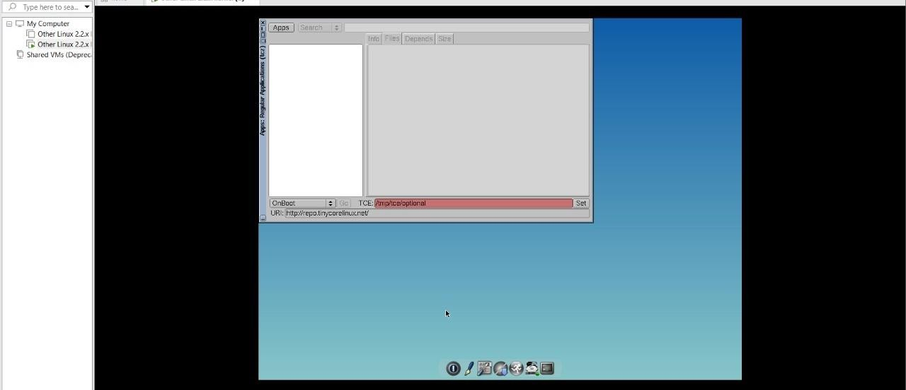

Result: The experiment was executed successfully